DSL Assignment06: testcases (Roll no: **21118**)

Testcase1: (Quicksort -> no duplicates)

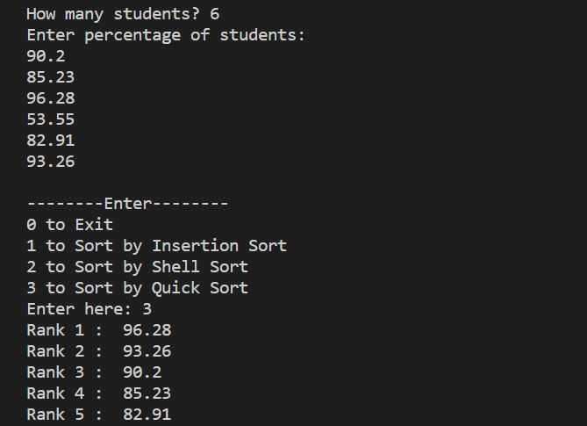

Testcase2: (Quicksort -> duplicates present)

